TFtP and copy command on cisco routers and switches
By: David Hannan
Abstract
A mini manual to help a user use the TFTP and copy commands on CISCO routers and switches.

This mini manual is to help a user to use TFP and the copy command on either a CISCO Router or Switch.

First you must make sure you know all the formation of your network.

IP Addresses
TFTP Server IP Address
Passwords for the CONSOLE port or SSH/ VTY

For this I will be using the following IP range 192.168.30.0 /24

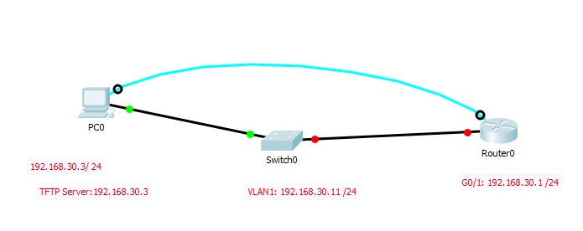

First you need to set up your pc’s network adapter.
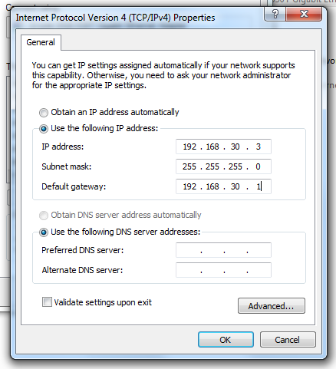

Then console into the switch and configure basic device parameters.

You will want to configure VLAN one with and IP address
S1#CONF T
S1(config)#int VLAN 1
S1(config-if)# ip address 192.168.30.11 255.255.255.0
S1(config-if)#no shut
S1(config-if)#exit
S1(config)# ip default-gateway 192.168.1.1
S1(config)#exit

Router config.

R1#conf t
R1(config)#int g0/1
R1(config)#ip address 192.168.1.1 255.255.255.0
R1(config)#no shut
R1(config)#exit

Once everything is set up you should be able to ping from the PC to S1 and PC to R1. The pings must be successful for this to work. You’ll then want to download and install a TFTP server software. For this I will be using CISCO TFTP Server software.

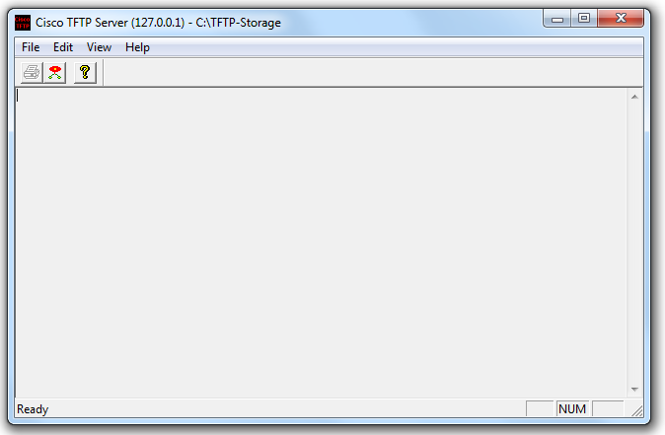

You will have to verify where the TFTP files will be stored at. That way you can find your files after transferring them to the server
The next step is to log into the router.
From the prompt you want to type in the following commands:
R1>en(nable)
R1#

This is where you be doing the copy run from.
You want to back up the OS of your router just in case it gets corrupt somehow.

R1# copy flash tftp
Address or name of remote host []? 192.168.30.3
Destination filename [c1900-universalk9-mz.SPA.151-4.M4.bin]? (enter)
!!!!!!!!!!!!!!!!!!!!!!!!!!!!!!!!!!!!!!!!!!!!!!
R1#

While the copy is going, and you are getting (!) exclamation points you are good to go until the copy completes. This part may take a few minutes.
If you get any .(periods) a fail happened somewhere, and you will need to redo it.

NOTE:
Do not rename the OS Cisco routers are very specific on their naming convention

Your TFTP server will also let you know if you were successful.

Now you want to copy the running configuration to the TFTP server.
The commands are as follows:

R1# copy running-config tftp
Address or name of remote host []? 192.168.30.3
Destination filename [Router-confg]? (here is where you will want to rename it if you want to) type in Router-confg.txt (this will save you file as a text file that can be editable)
!!
1465 bytes copied in 0.663 secs (2210bytes/sec) (only an example of what you might see, some config files may be bigger)
R1#

You will then do the same to copy the switch’s configuration and OS to the TFTP Server.

To load from the TFTP Server you would want to do the following

Router>en
Router#copy TFTP running-config
Address or name of remote host []? 192.168.30.1
Source file name []? Router-Confg.txt
Destination filename [running-config]? (hit enter)

The router/switch will access the tftp server
Accessing tftp://192.168.30.1/router-confg.txt
If it doesn’t work, you will get the following
% Error opening tftp://192.168.30.1/ reouter-confg.txt (got this because I put in the wrong IP address.)

Here is what it should look like with a successful copy.

Router#copy tftp running-config
Address or name of remote host []? 192.168.30.3
Source filename []? Router-confg.txt
Destination filename [running-config]? (enter)

Accessing tftp://192.168.30.3/Router-confg.txt...
Loading Router-confg.txt from 192.168.30.3: !
[OK - 621 bytes]

621 bytes copied in 0.001 secs (621000 bytes/sec)
Router#
%SYS-5-CONFIG_I: Configured from console by console

The configuration was successfully loaded now you want to do the following.

Router#copy run start
Destination filename [startup-config]? (enter)
Building configuration...
[OK]
Router#

And that is it for TFTP and copying to and from a router/switch.

